

**Project2: Student Info system**

Eng. Ali Mohamed Taima



Learn in depth

Mastering Embedded System online diploma

Eng. Keroles

# Add the student details from text file

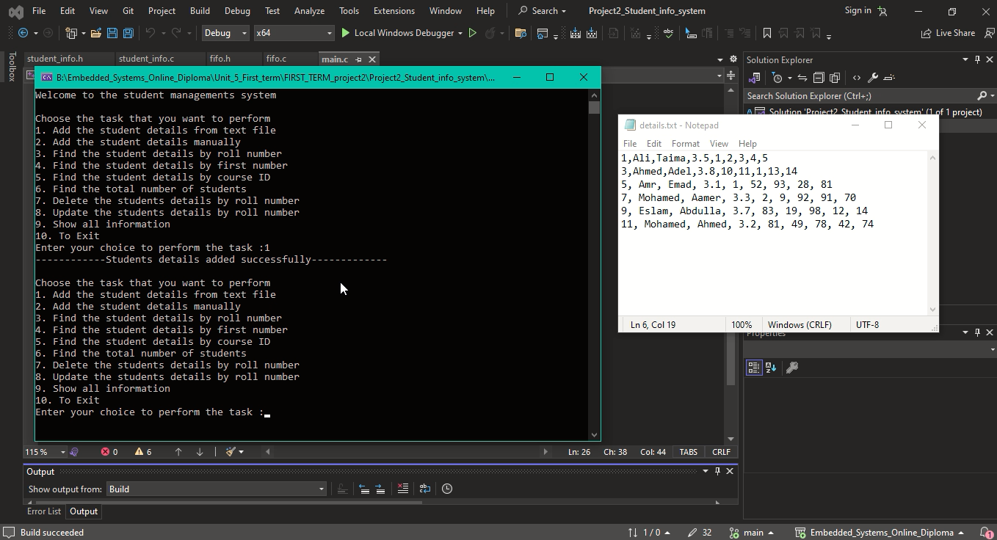

# Add the student detail manually

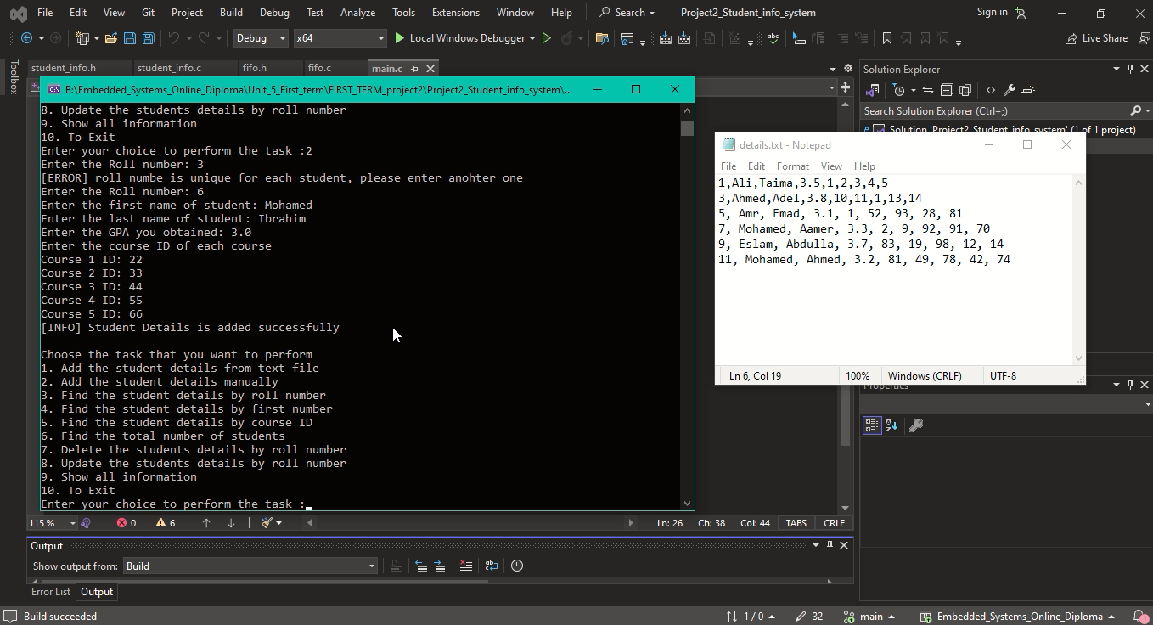

# Find the student details by roll number

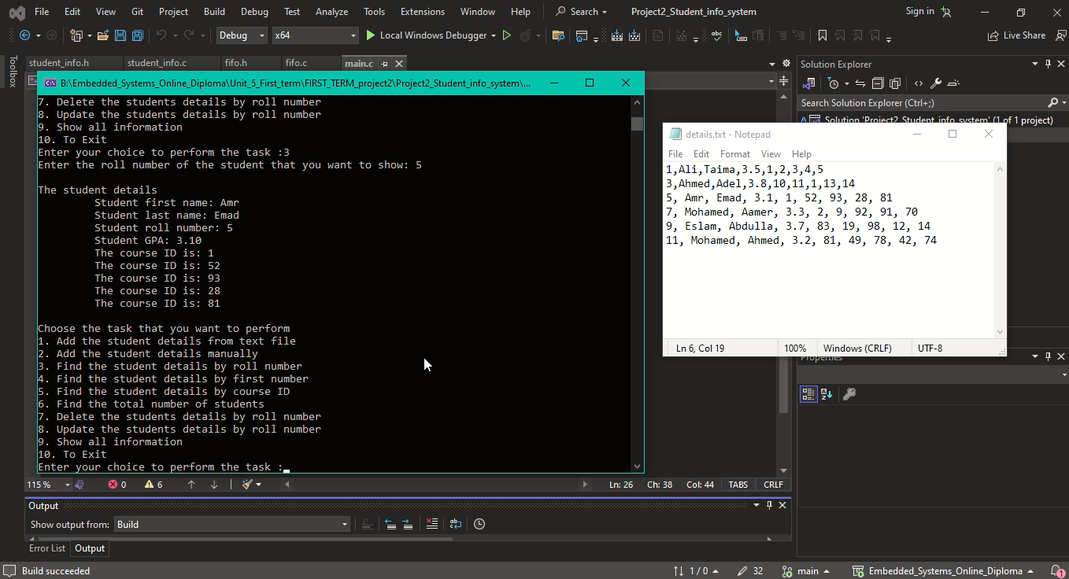

# Find the student details by first number

# Find the student details by course ID

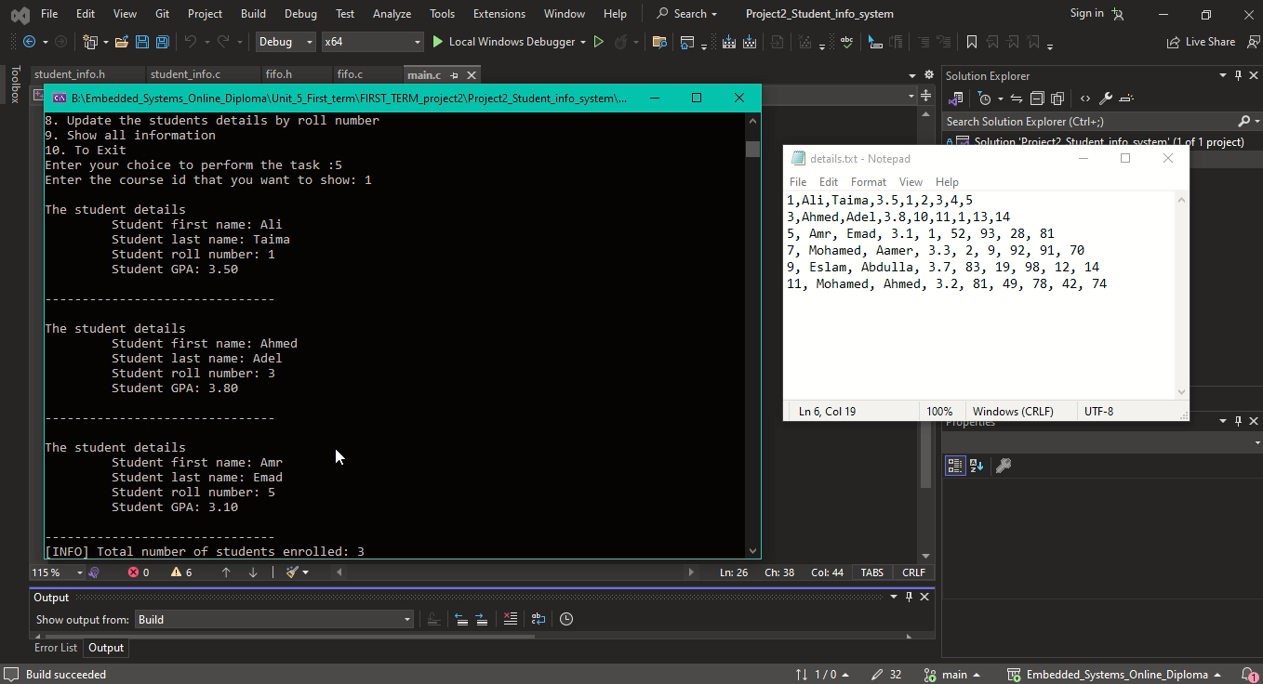

# Find the total number of students

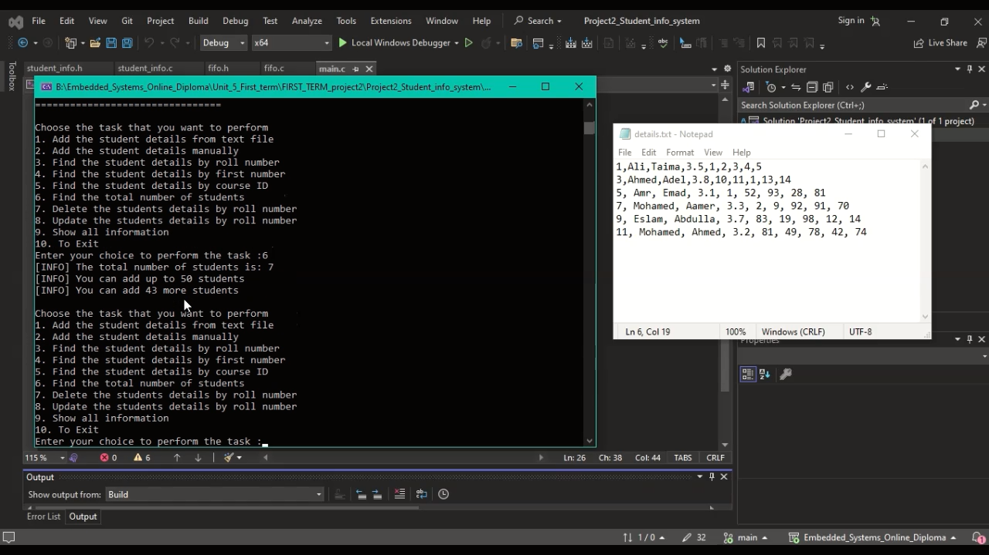

# Delete the students details by roll number

# Update the students details by roll number

## GPA

## A screenshot of a computer Description automatically generated First Name

## roll number

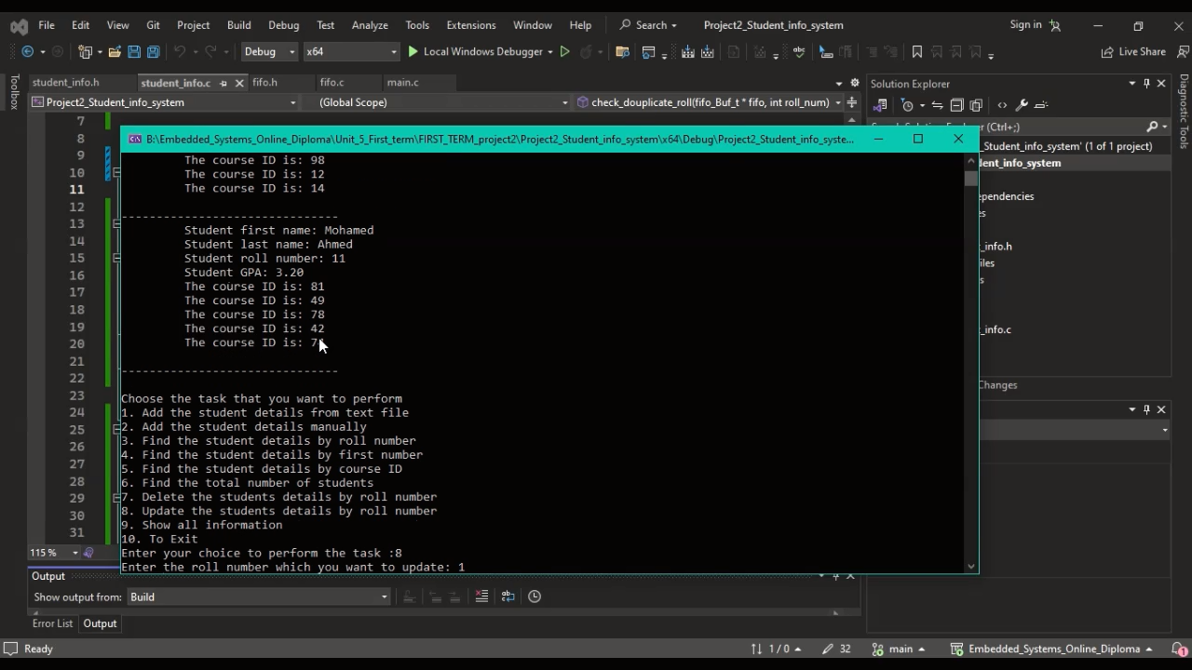

## A screenshot of a computer Description automatically generatedCourses

# Show all information

# To Exit

